Key (Unit 4, page 50)
Exercise 1a
Exercise 1b
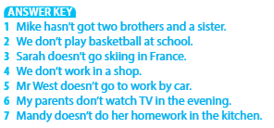
Exercise 2
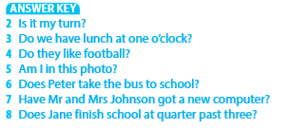
Exercise 3
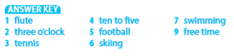
Exercise 4a
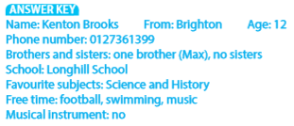
Exercise 4b
